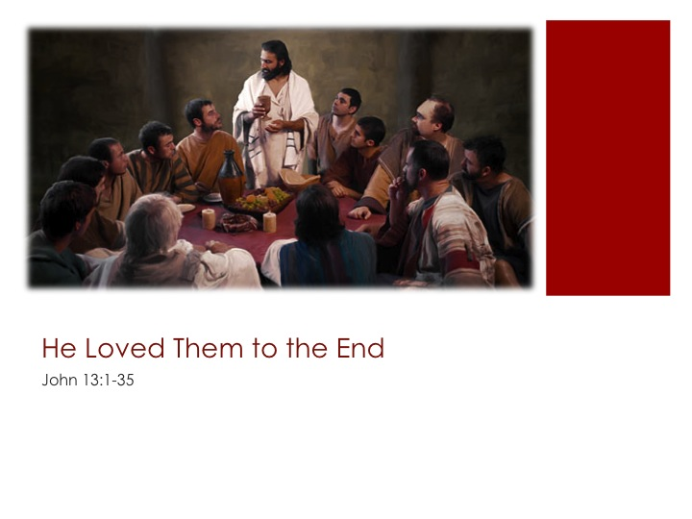
Sermon Study Guide

“So why did Jesus choose such men as disciples? On answer is that the Savior knew that selecting people as followers whose lives were headed in the opposite direction of all He stood for would demonstrate the power of the gospel to change selfish hearts. He knew that such men would make marvelous allies if He could turn their longing to destroy into a longing to love.” The Gift, p. 40, Kim Allen Johnson
Read Luke 22:15
“Jesus intended for this evening to be etched deeply on the memories of His followers. Every word and action was important. It was an unrushed few hours before the gathering storm. It was a time for enjoying friendship and privileged intimacy; a time for His followers to be formed into a unique team; a time for dramatic symbols and actions…” In the Steps of Jesus, p.159, Peter Walker

Read John 13:1-4
1. He loves you to the end… knowing your _____________________________________.
- Verse 1: Jesus knows that ________________________________.
- Verse 3: Jesus knows the Father __________________________, that _______________ God and ______________________ God.
- Verse 11: Jesus knows who ________________________.
- Verse 18: Jesus knows who _______________________________.
Read Luke 22:24
Read Luke 22:27

Read John 13:5
2. He loves you to the end… by________________________________ in humble service.
Read John 13:14, 15 & 17

Read John 13:34-35
3. He loves you to the end…so that, following His example, you_______________________.
“The Lord’s desire was that the oneness among the disciples, and His people down through time, would be so counterculture, so profoundly different from society at large, such a source of amazement, that unbelievers would acknowledge it had to be supernatural. Words are cheap, but a living demonstration cannot be denied. The Spirit of Prophecy indicates that “…the strongest witness that God has sent His Son into the world is the existence of harmony and union among men of varied dispositions who form His church.” The Team, p. 110, Kim Allen Johnson
“Only by love is love awakened. To know God is to love Him…” Desire of Ages p. 22, Ellen G. White

Share your decision for Christ today at pastorcousins@rpcsda.org

